User Story: Budget Estimation for Expenditure by BCO
User Story ID | BEL_BM_IFMIS_Budget_Estimation_Expenditure
Module Name | Budget Management
BEL Contact Person | Kamal Saryam, Shrikant Tirki and Gaurav Singh
DTA SPOC Person | Vivek Gharu
DTA Technical Person | Abhay Borikar

User Story:
- As a BCO Creator, I want to submit the budget estimation for Expenditure for Verification.
- As a BCO Verifier, I want to review, edit and forward the Budget estimation for approval.
- As a BCO Approver, I want to review, edit and approve the budget estimation.

Pre-Conditions
- Budget Line Items to be mapped with BCO.
- Department-wise ceilings defined and approved by FD.
- Budget module activated by Finance Department.
- Budget Submission date within the time limit as per Budget Circular.

Process Flow
  - Data Synchronization:
Based on Employee login, BCO linked with department details are fetched from HRMS through secure API.
  - Auto-Fetch Components:
System retrieves all budget line items assigned to BCO.
System retrieves actual Expenditure for budget line items occurred during previous 5 years.
System retrieves the Budget Allocation of previous year.
  - BCO Creator:
BCO Creator receive file from multiple DDO for verification and compilation. OR
BCO Creator can also create Budget Estimates by himself. To create Budget estimate He selects the budget line item and enters the budget estimation for next 3 years and revised estimation for current year for Expenditure and Expenditure separately.
BCO Creator enters the data for each budget line item and saves.
BCO creator can create and enter token amount for new budget line for approval by Finance department (Assembly).
BCO Creator submits to verifier once all budget line data is ready
  - Rule Engine Validation:
Budget Estimate submitted should not be more that overall ceiling limit for Expenditure. If limit is exceeded display error message
  - BCO Verifier:
BCO Verifier views the budget estimation submitted by BCO creator. BCO Verifier can either edit or return to BCO Creator or forward the file to BCO Approver.
BCO verifier can also create new budget line and enter token amount for approval by Finance department.

  - BCO Approver:
BCO Approver views the budget estimation forwarded by BCO verifier. He can either edit or return to BCO Verifier or approve the file.
BCO verifier can also create new budget line for Expenditure and enter token amount for approval by Finance department.
The approved budget will be sent to Admin HOA
  - Audit Trail and Reporting:
Each action creation, modification, verification, approval, rejection logged for audit.

Process Flow Diagram:

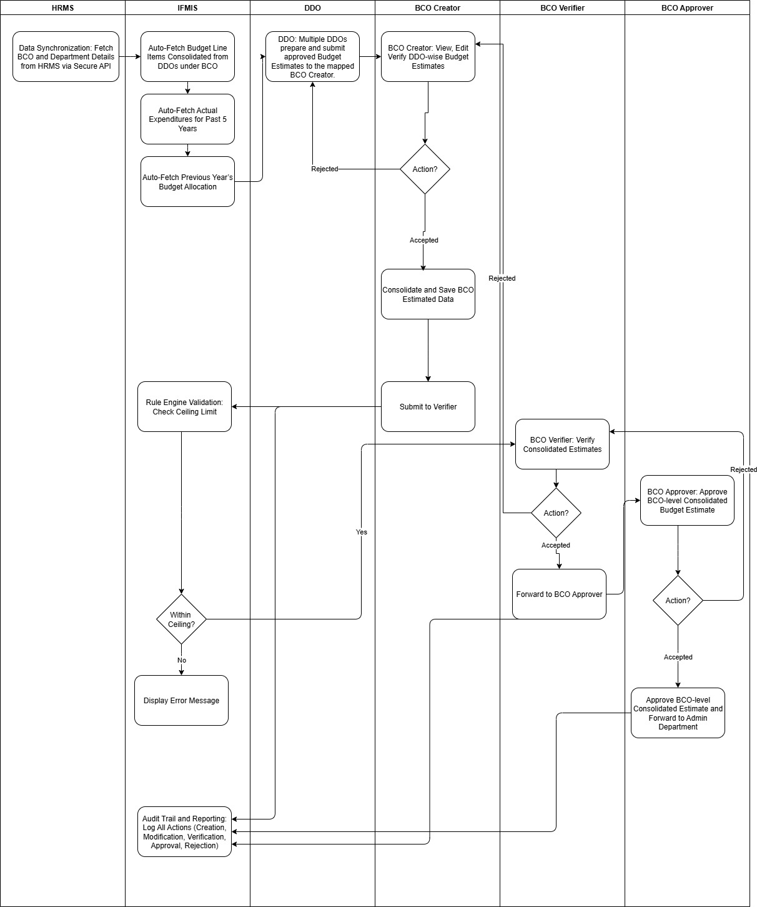

Rule Management / Business Logic:
_{Rule ID} | _{Rule Name} | _{Category} | _{Trigger / Event} | _{Input Parameters / Data Fields} | _{Logic / Formula / Condition} | _{Effective From} | _{Owner Department/Editable By} | _{Parameter Name} | _{Data Type} | _{Value Range} | _{Current Values} | _{Source / Master Table} | _{Remarks}
₁ | _{Check Ceiling Limit} | _{Budget Module} | Enter or Edit of Budget Estimate | _{Budget Estimate} | _{BE>Ceiling Limit} |  | _{Budget Module} |  | _{Numeric}

Acts/Rules/Circulars Governing the Process Flow:
- Provisional Budget Program for Revised Estimates and Budget Activities for FY 2024–25 and Preparation of Budget Estimates for FY 2025–26 (dated 25-09-2024)
- Madhya Pradesh Financial Code Vol. I & II
- Treasury Code Rules & Budget Manual of GoMP
- FD Circulars regarding ceiling fixation, budget submission, and timeline adherence

Acceptance Criteria (End of Process):
- Budget Estimation is created, verified and approved for Expenditure for all the budget lines items and submitted to BCO.

Actors Involved:
Level | Actor | System Role | Description of Responsibility
1 | BCO Creator | BM_BCO_Creator | Creates the Budget Estimation and submits for verification.
2 | BCO Verifier | BM_BCO_Verifier | Verifies the Budget Estimation submitted by BCO Creator.
3 | BCO Approver | BM_BCO_Approver | Approval of Budget Estimation

GAP Analysis
Current Process | Gap Identified | Proposed To-Be Process
BCO Submission of Estimation | Currently choosing each budget line item and entering data is tedious task. | Budget estimated amount will be suggested based on past data
No audit trail | Compliance gaps | Logging of each activity and fields modified

Internal Module Integration Requirements:
Interface ID | Interface Name / Purpose | Source Module | Target Module | Direction | Trigger Event | Fields (in single cell)
IFMIS_INT_EHRMS_01 | e-HRMS → IFMIS HRMS (Employee Data Sync) | e-HRMS | IFMIS HRMS | Inbound | On Budget Estimate Selection | EMP_ID; NAME; DESIGNATION; DEPARTMENT;
IFMIS_INT_ACCOUNTS | e-Accounts->Get Actual Expenditure | Accounts | Budget | Inbound | On Budget Line Item | Budget Line Item
IFMS_INT_DEBT | Debt->Get Interest and Principal | Debt | Budget | Inbound | On Budget Line Item | Budget Line Item

Integration with External Systems:
Not Applicable

Fields, Field Types, Field Length, Field Validation:
Expenditure
Field Name | Unit (UI Component) | Field Type | Field Length | Mandatory (Y/N) | Validation Rule | Remarks
Demand No | Auto populate |  |  | Y |  | Display of Budget line item
Major | Auto populate |  |  | Y |  | Display of Budget line item
Sub Major | Auto populate |  |  | Y |  | Display of Budget line item
Minor | Auto populate |  |  | Y |  | Display of Budget line item
Segment Head | Auto populate |  |  | Y |  | Display of Budget line item
Scheme | Auto populate |  |  | Y |  | Display of Budget line item
Project | Auto populate |  |  | Y |  | Display of Budget line item
Charged or Voted | Auto populate |  |  | Y |  | Display of Budget line item
Object Head | Auto populate |  |  | Y |  | Display of Budget line item
Detail Head | Auto populate |  |  | Y |  | Display of Budget line item
Departmental Account for Previous Year | Auto populate |  |  | Y
Budget Allotment for Current Year | Auto populate |  |  | Y
Actual Expenditure as on 31 Aug XXXX | Auto populate |  |  | Y
Proposed Expenditure for Sep XXXX to Mar XXXX | Auto populate |  |  | Y
Total | Calculate |  |  | Y |  | Actual Expenditure+ Proposed Expenditure
Amount proposed for Revised estimate (Current Year) | Input | Numeric | 0 to 999999999999 | Y
Amount proposed for Main Budget (Next Year) | Input | Numeric | 0 to 999999999999 | Y
Percentage Deviation | Calculate | Numeric | 0 to 100 | Y
Amount proposed for Main Budget (Next Year+1) | Input | Numeric | 0 to 999999999999
Amount proposed for Main Budget (Next Year+2) | Input | Numeric | 0 to 999999999999
‘Previous 5 years' actuals’ | Auto populate
Project Details | Auto populate
Remarks | Input | Text | 1000 Chars

Masters
- Budget Line Items
- Department

UI / UX Requirement:

Web Application:
- BCO Creator Dashboard with List of Budget Line Items along with status.
- Status –Draft, Under Verification, Verified, Under Approval, Approved.
- BCO Creator Entry interface with remarks field.
- BCO Verifier Worklist with Pending Files for verification.
- BCO Approver Worklist with Pending Files for approval.
- Option for BCO Verifier and Approver to edit, enter remarks, return or reject.

Mobile Application:
- NA

AI / ML Use Cases:
- Suggest budget estimation and revised estimation amount
- Identify anomalies in budget estimate and alert based on history.

Reports:
- Budget Estimate Report
- Budget Estimate Status Report
- Ceiling Compliance Report
- Audit Trail Report

Dashboard Requirement:
- KPIs: Total Estimation Requested.
- Real-time Approval Status Widget.

Requirement for Notifications/Alerts:
Notification ID | Trigger | Recipient | Mode | Message Summary
NTF_BM_01 | BCO Creator Submit Budget | BCO Verifier | App Notification | “Budget Estimate Received for Verification”
NTF_ BM_02 | BCO Verifier Submit Budget | BCO Approver | App Notification | “Budget Estimate Received for Approval”
NTF_ BM_02 | BCO Approver Submit Budget | Admin HOA | App Notification | “Budget Estimate Received for Approval”
NTF_BM_03 | Rule violation detected | BCO Creator | Alert | “Budget Estimates limit exceeds”

Error Messages:
Error Code | Condition | Description
ERR_AD_01 | Sync Failure | Employee record missing from e-HRMS
ERR_AD_02 | Rule Engine Validation Failed | Ceiling limit exceeded
ERR_AD_03 | Workflow Hold | Already Submitted

IFMIS DB Table Reference:
  - Master Table:
Sl No | IFMIS 1.0 Table | IFMIS NG Table | Data Migration Remarks | Remarks

  - Transaction Table:
Sl No | IFMIS 1.0 Table | IFMIS NG Table | Data Migration Remarks | Remarks

Wireframe:

Unit Test Cases:

